MACH4METAL

metalworking machinery
Transito 21,
6909 DA BABBERICH, Netherlands
Tel. + 31 (0)316 – 247123
Fax. + 31 (0)316 - 247956

Bank No : 66.52.13.883
IBAN : NL33 INGB 0665 2138 83
BIC : INGBNL2A
info@mach4metal.com www.mach4metal.com www.mach4metal.com

GEMINIS Lathe Ø 870 x 1500 mm

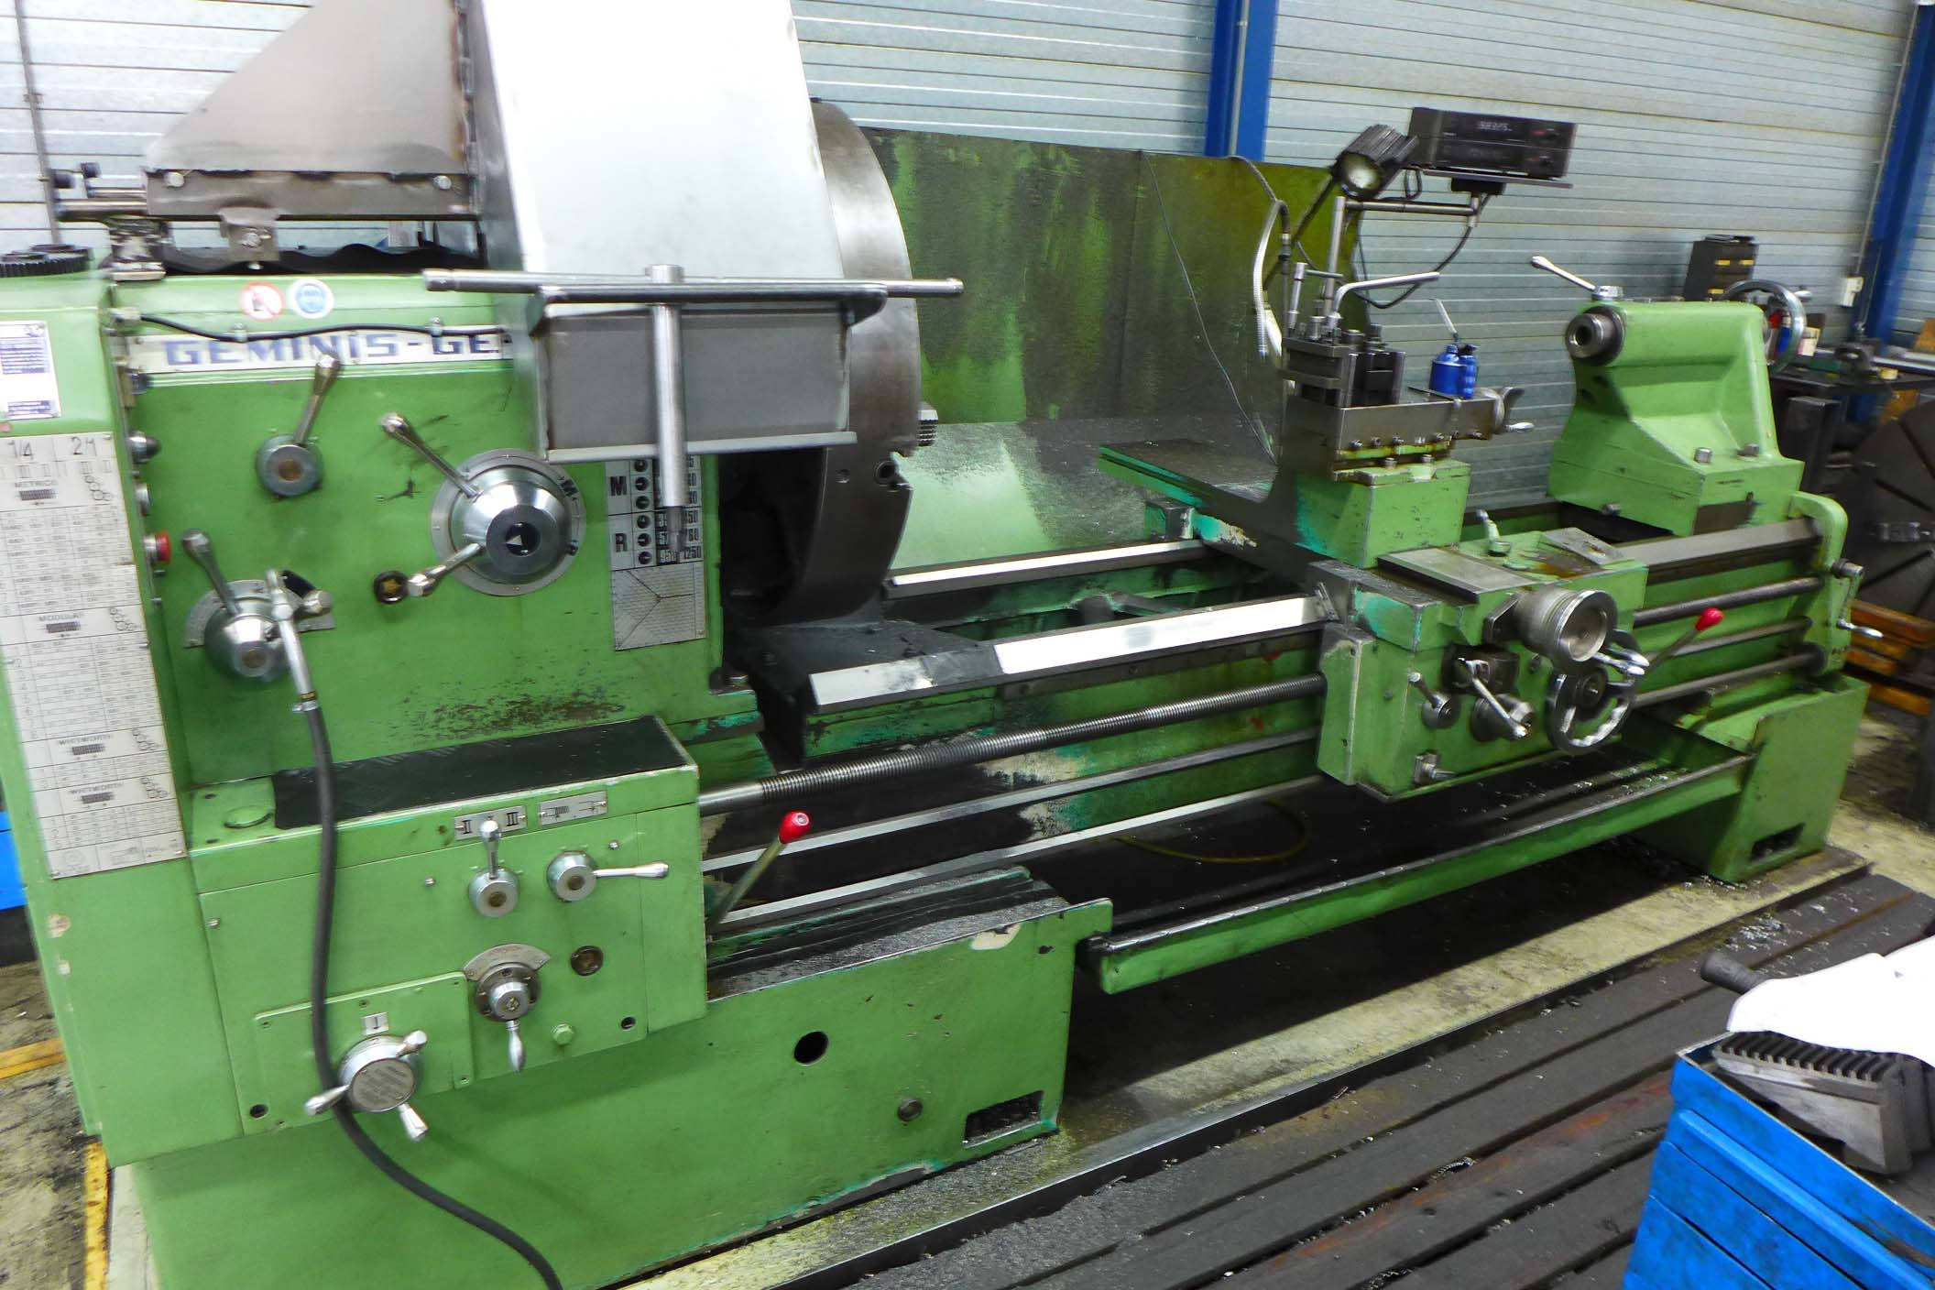
- Make : Geminis Spain
- Typ : GE 870
- Age : 80 er
- Mach.No. : 2910 02407

- Max. turning Ø over bed : 870
- Max. turning Ø over carriage : 580
- Max. turning Ø in the gap : 1.100
- Centre height : 430
- Centre distance : 2.000

- Bed width : 550
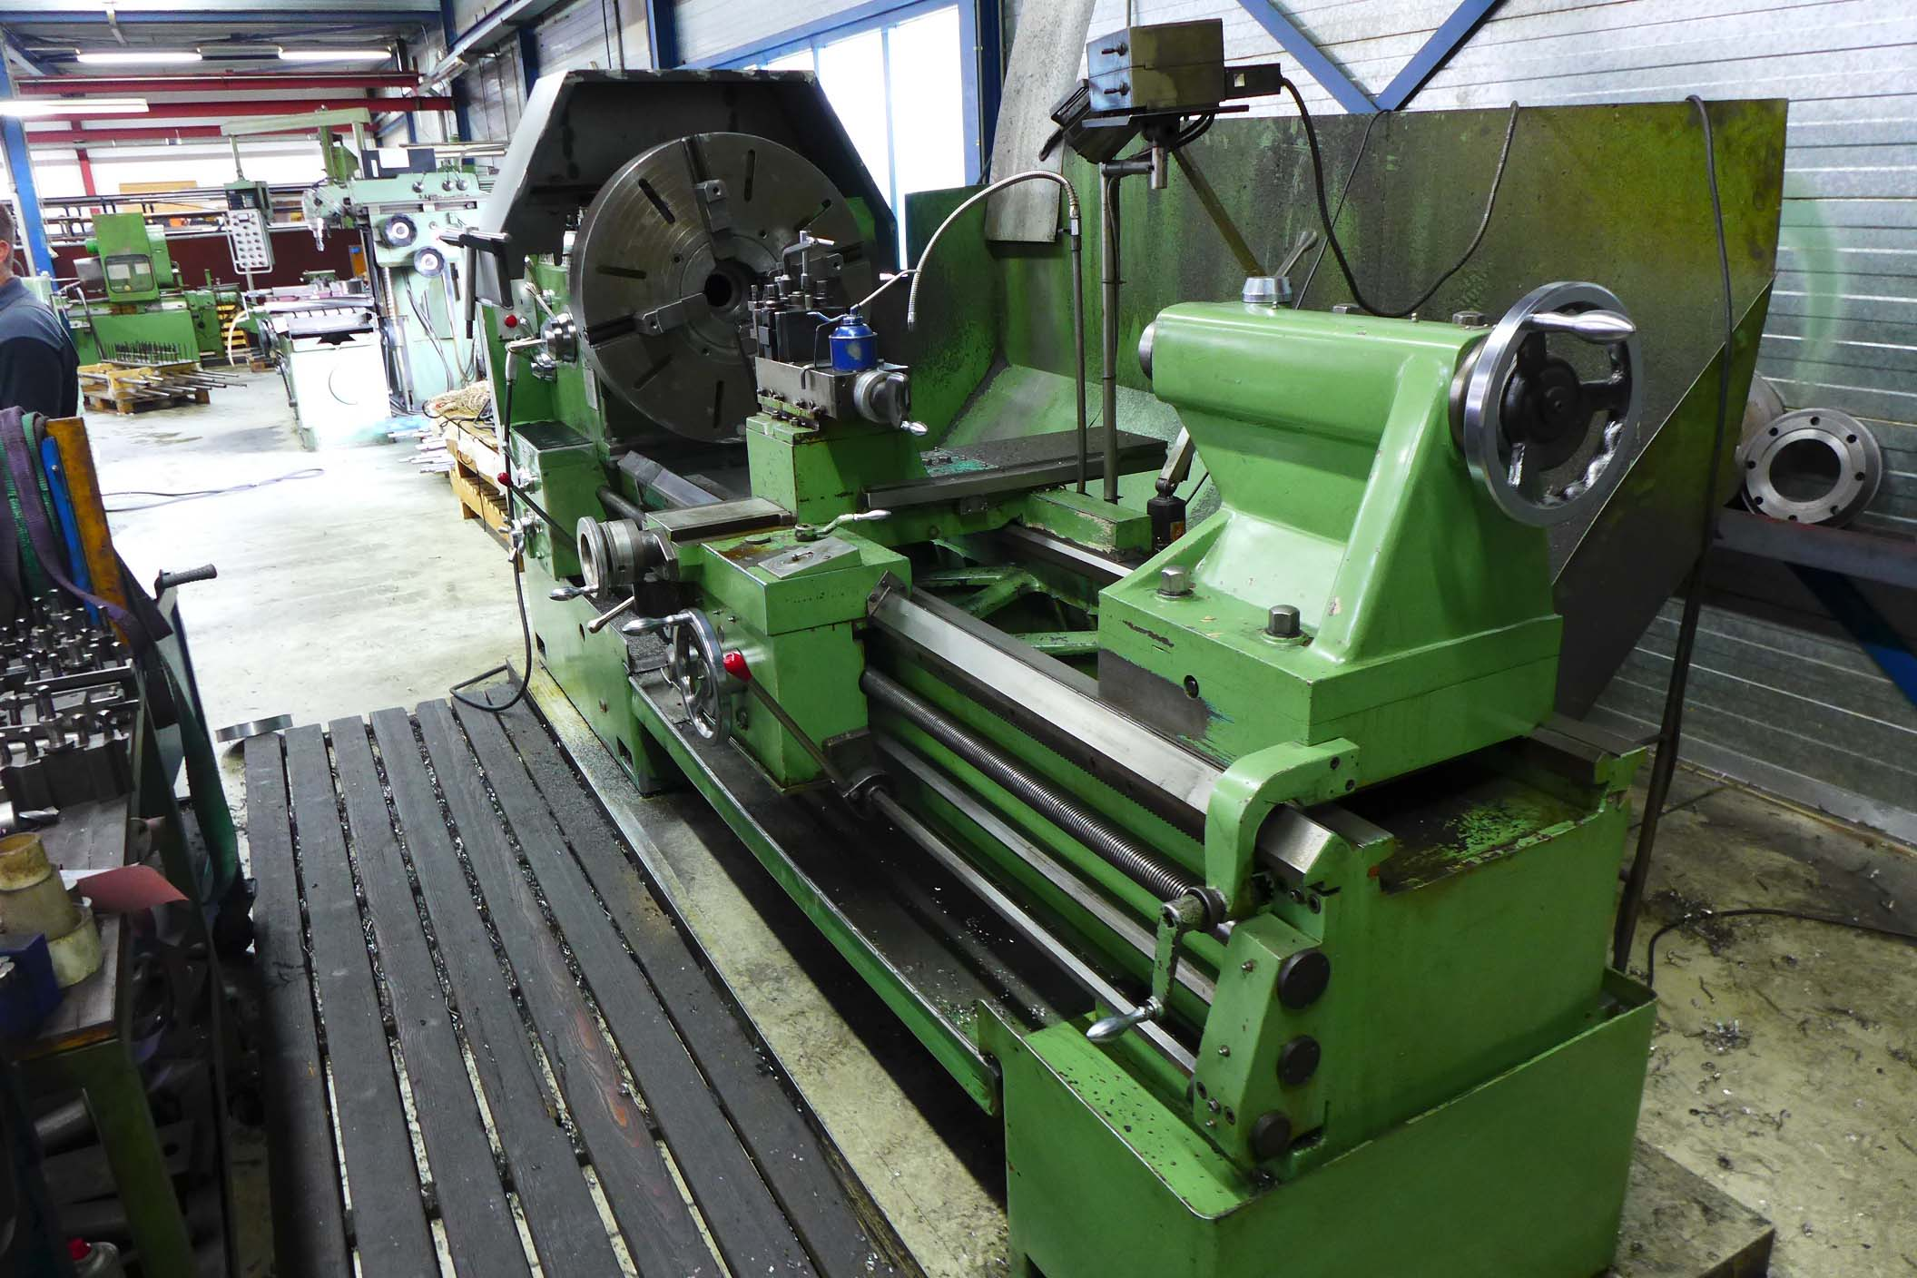
- Number off guide ways : 2
- Work load between centre : 3.000

- Spindle bore : 82
- Speeds 24 x : 1.250
- Power : 15 kW

- Tool system with 10 inserts
- SONY Digital read out 2 axis
- 4 chuck ca 800 mm
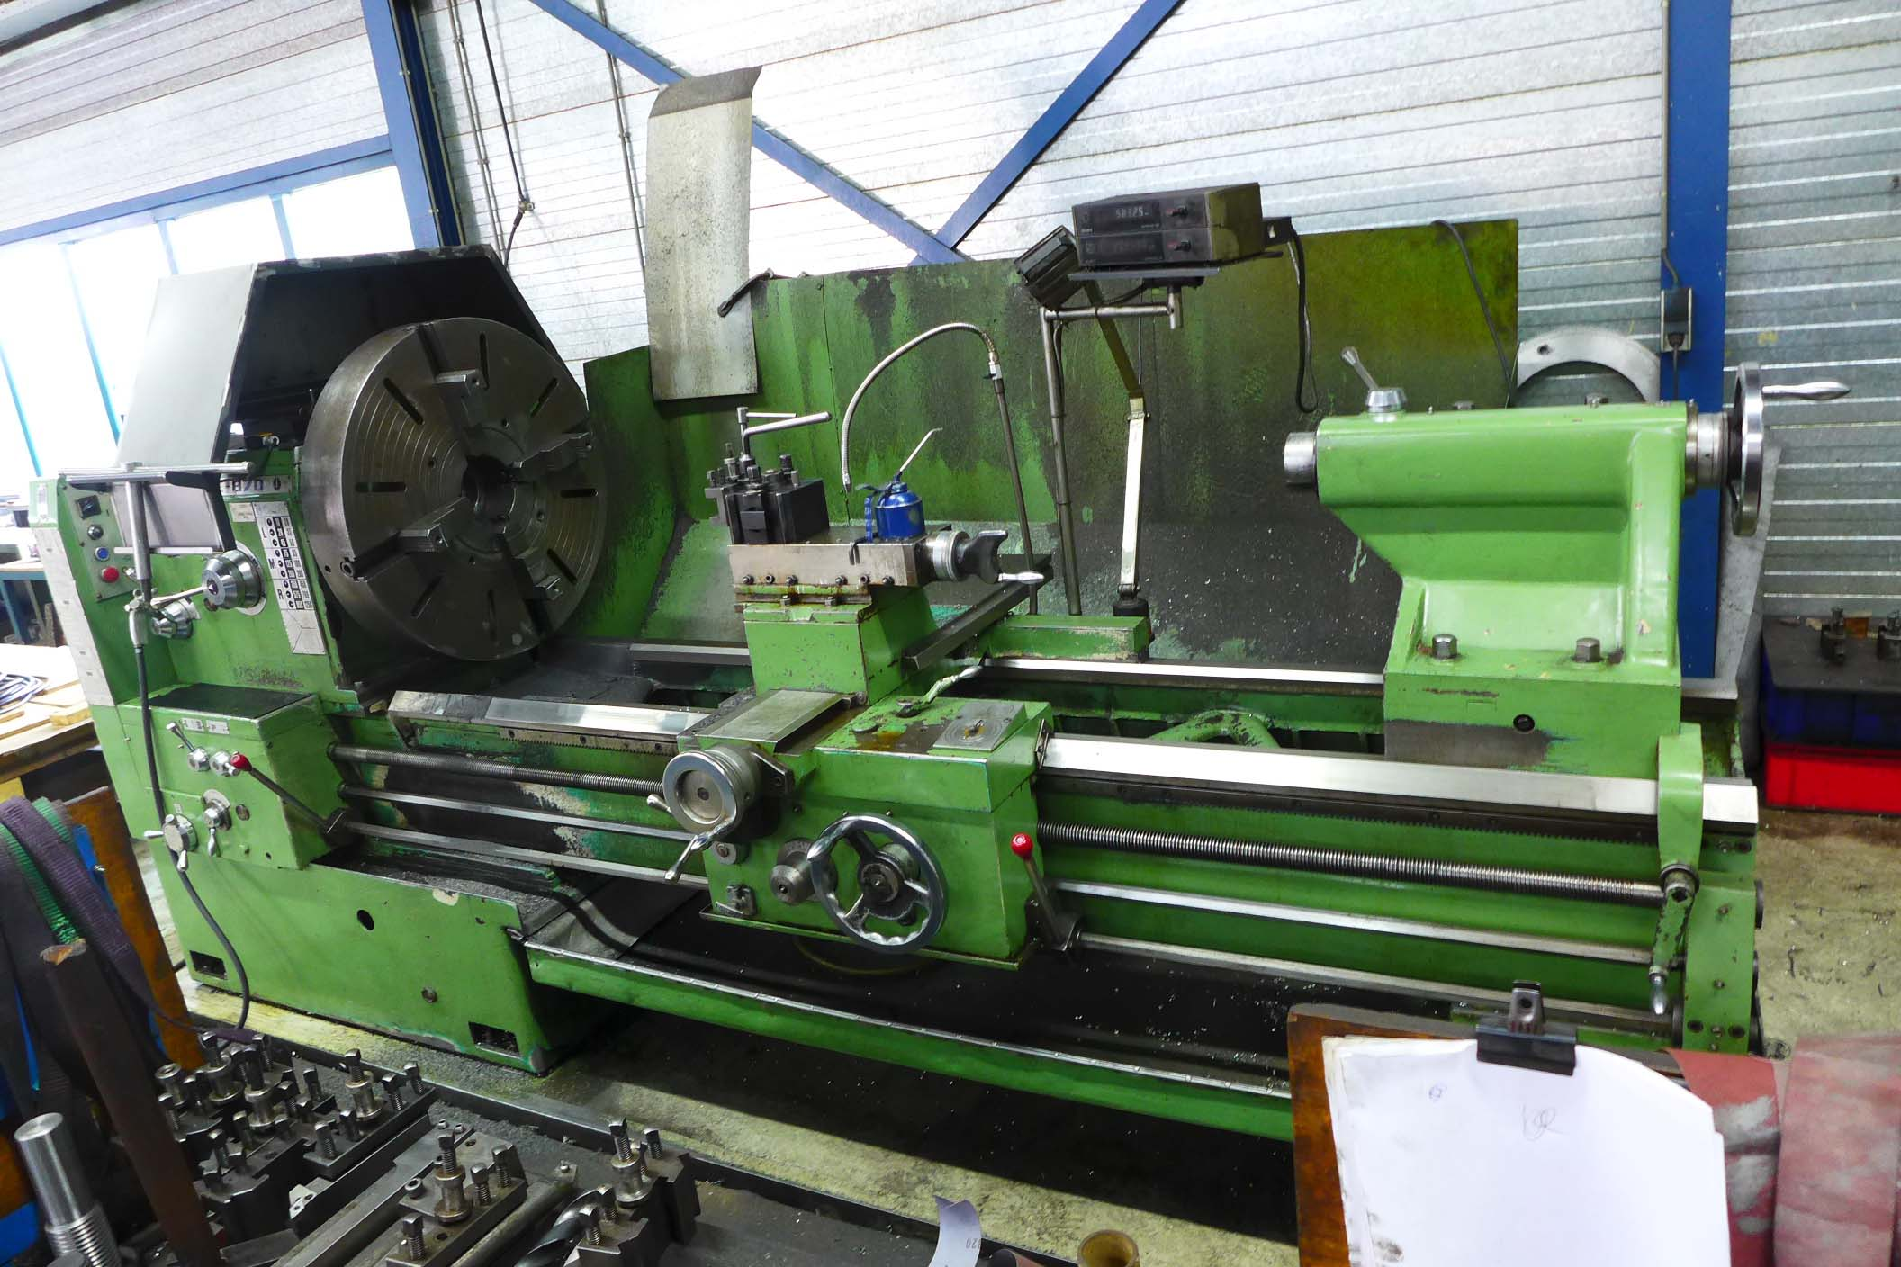

- Dimensions
- Length : 3.500
- Width : 1.700
- Height : 1.800
- Weight : 4.200

Please Note: The above information has been obtained to the best of our ability and belief from, and from the manufacturers where possible. It is given in good faith, but its accuracy can not be guaranteed. Accordingly, it will not form a representation or constitute contractual terms. We advise you to check any vital details!

